**FAISAL RASOOL QAZI**

**455689**

**ME 15 SEC B**

#include <iostream>

using namespace std;

**//TASK 01**

// int main() {

// int sum = 0;

// for (int i = 1; i <= 10; ++i) {

// sum += i;

// }

// cout<<"Sum of first ten natural numbers is "<<sum;

// return 0;

// }

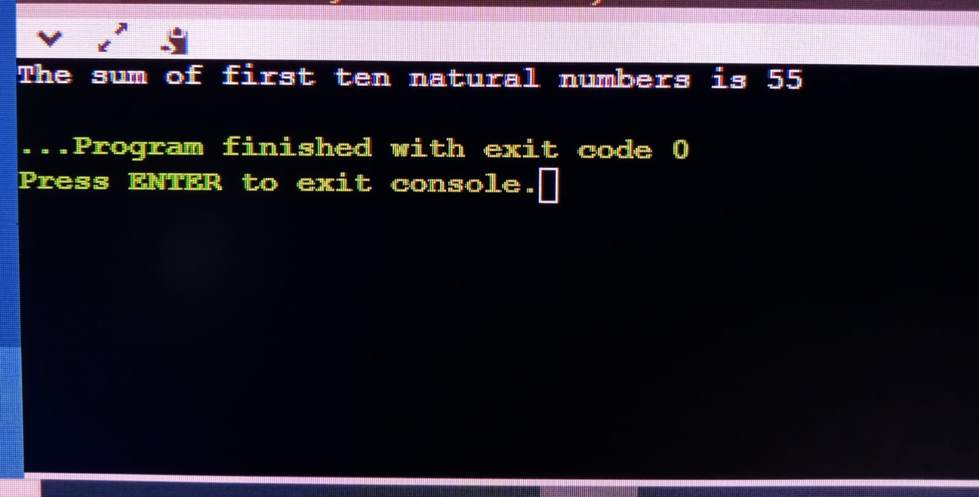

**//TASK 02**

// int main() {

// int number = 2;

// for (int i=1; i<=2;++i) {

// cout<<number<< "*" << i << "= " <<number* i<<endl;

// }

// return 0;

// }

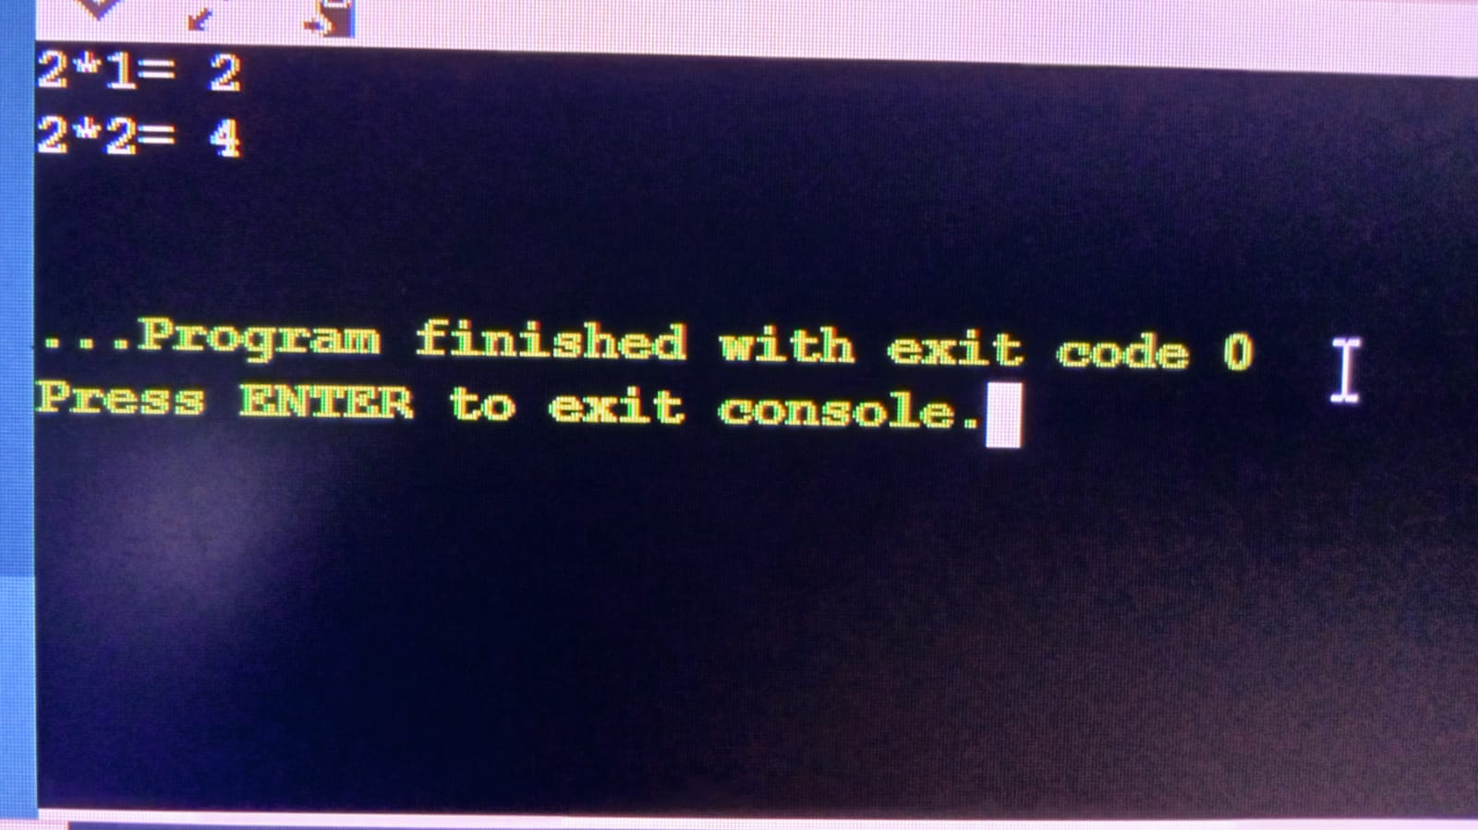

**//TASK 03**

// int main() {

// int number;

// cout << "Enter an integer"<<endl;

// cin >> number;

// int factorial = 1;

// for (int i = 1; i <= number; ++i) {

// factorial *= i;

// }

// cout << "It's factorial is " << factorial;

// return 0;

// }

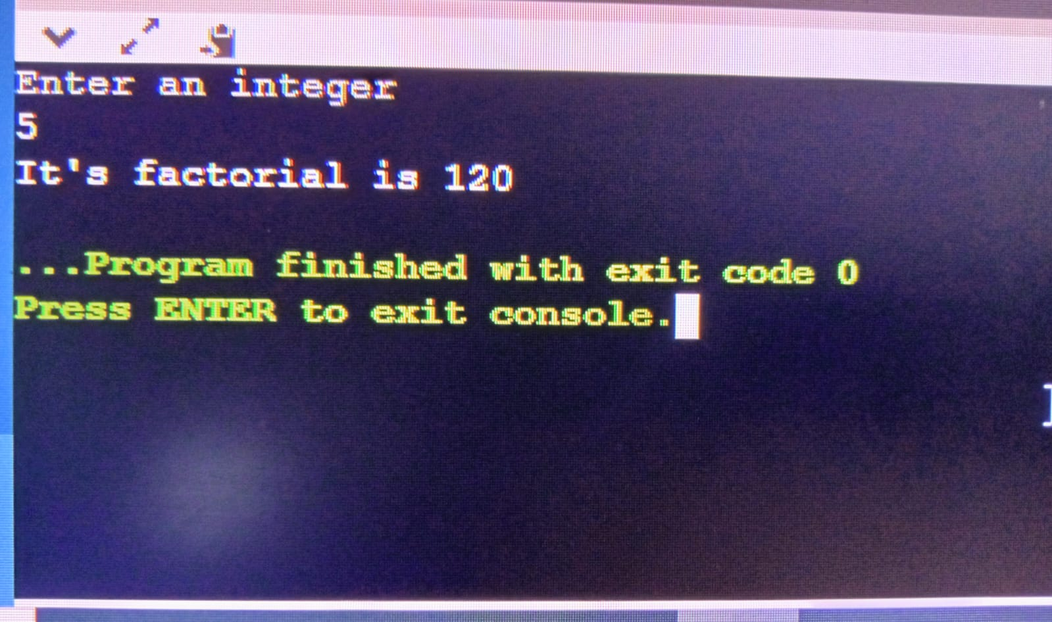

**//TASK 04**

int main() {

int limit;

cout<<"Enter a certain number to get Fibonacci sequence till the num:"<<endl;

cin>>limit;

int first = 0, second = 1, next;

cout << "Fibonacci sequence: " << first << ", " << second << ", ";

while (first + second <= limit) {

next = first + second;

cout << next << ", ";

first = second;

second = next;

}

cout << endl;

return 0;

}

